OPRE 6301: Marketing Management

**Project Report:**

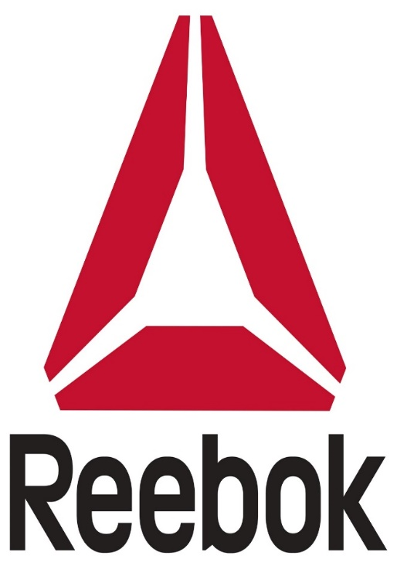

*Group 9:*  
Aditya Thakur (ast160830)  
Kshitij Sagar (kxs169330)  
Nidhi Maru (nxm170430)  
Venkata Naga Satya Sangeeta Eluri (vxe160230)  
Veerbhadra Deepak Satya Ayyagiri (vxa163330)

Contents

1. Footwear Industry and its evolution
2. Products and Services
3. Challenges faced by Footwear Industry
4. Company
5. What is the need?
6. Current Market and Competition analysis
7. STP Analysis
8. SWOT Analysis
9. Proposed Market Strategy
10. Future Scope and Conclusion

**Footwear Industry and its Evolution:**

Shoes are vital to man’s sole. It is no secret that feet manage the challenges of daily life with the help of shoes. Shoes can stabilize, allow for flexibility or rigidity and cushion feet. With the evolution of fast-paced lifestyles shoes have been scientifically engineered to provide the most comfort. Footwear market comprises of athletic and non-athletic type of shoes. Their mode of sale would be online or retail, with end users being men, women and children. Specifically, the Sports Shoe (Athletic) industry has grown strongly over the five years to 2017 due to economic growth and rising sports participation. Furthermore, increased athletic activity puts more wear and tear on athletic shoes, necessitating more frequent purchases to replace worn-out footwear.

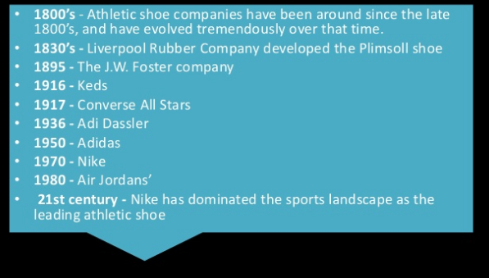

**Products and Services:**

There are various kinds of products and services that are being offered by a shoe company to engage more people into the chain of supply. However, shoes play a dominant role. Athletic Industry focuses on the marketing principle of “making what they can sell”. The starting point for the analysis of consumer behaviour in sports is the theory of consumer demand. Consumers tend to have a set of tastes and preferences while facing a given set of prices of goods and services. They allocate their income to maximize utility, which results in a spending pattern where the relative marginal utilities of different goods are equated to relative prices. This modelling approach often adopts a hierarchical behaviour – In the demand for the sporting activity, sports shoes are playing the role of parent demand function and the demand for sports facilities, sports equipment, and sports clothing are treated as derived demands from this logically prior parent demand. For example, when a person decides to play badminton, he/she will require sports shoe as a principal demand, but as merchandised products he/she will also require clothing, cap, shuttlecocks, racquet etc. Ultimately, if the demand for sports shoe increases, then there are pretty good chances that the additional merchandised products demand might also increase. According to our survey, 33.6% of respondents said that they purchased new items specifically for sports in order to look better while playing sports.

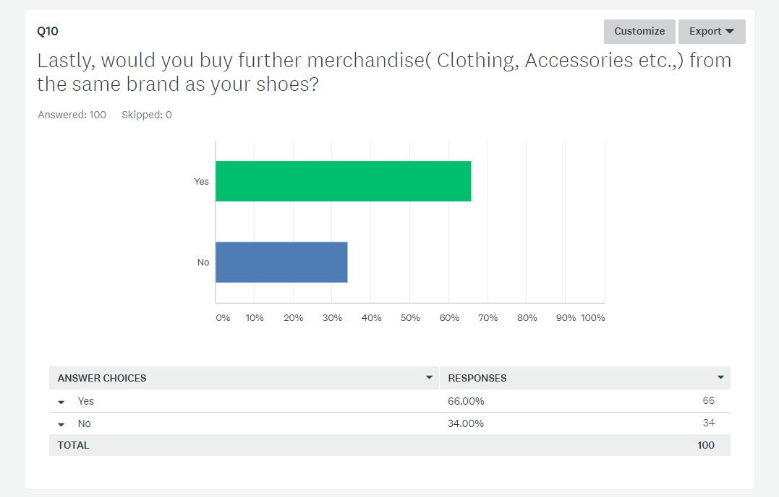

**Challenges faced by Footwear Industry:**

**Emerging trends in sports and fitness**

Obesity is a major health issue in developed countries, such as U.S. and Europe, with one out of three persons being obese. People are focused on activities such as yoga, gym, and jogging to combat obesity. Hence, the demand for athletic footwear is higher in these countries. The rising health awareness among consumers is expected to further increase this demand in the coming years.

**Changing consumer lifestyle**

Urbanization is an important factor that influences consumer lifestyle. According to the Population Division (2017) of the United Nations, 54.5% of the world’s population resided in urban areas in 2017, and by 2050, 66% of the world’s population is expected to move to urban areas. North America, Latin America, and Europe are the most urbanized regions with a large consumer base and emerging fashion trends. The changing consumer lifestyle is expected to increase the demand for the athletic footwear in the coming years.

**Emerging role of e-commerce**

E-commerce, or electronic commerce, which involves buying and selling products and services exclusively through electronic channels, has a huge demand globally. The most well-known form of e-commerce is online shopping. E-commerce has simplified the purchasing process for consumers by making it easier and more convenient. The current retail scenario is different from what it was ten years earlier. The industry has a huge opportunity owing to the emergence of e-commerce, which makes shopping simpler, easier, and more convenient.

**Company:**

Reebok International Limited, a subsidiary of the German company Adidas since 2005, is a producer of athletic shoes, clothing, and accessories. The name comes from the Afrikaans spelling of rhebok, a type of African antelope or gazelle. In 1895, Joseph William Foster his ideas progressed he joined with his sons, and founded a shoe company named J.W. Foster and Sons. In 1958, two of the founder’s grandsons Joe and Jeff Foster renamed the company Reebok in the United Kingdom. In 1979, Paul Fireman, an American sporting goods distributor, saw a pair of Reeboks at an international trade show and negotiated to sell them in the U.S.

Mission: Challenge and lead the fitness world through creativity.

Vision: Fulfilling Potential

Tagline: I am What I am

**What is the need?**

Sports shoes tend to fulfil the following needs:

**Increasing use of eco-friendly products**

With the growing need for the preservation of the environment, most consumers today have started demanding sustainable products. Vendors are catering to this demand by increasingly focusing on manufacturing products, such as organic cotton, recycled rubber, plastic materials, and water-based adhesives that can reduce negative impact on environment. For example., Reebok said that it participated in the adidas group initiative to use 100% sustainable cotton in their products by the end of 2018. 'Sustainable cotton' means Better Cotton, certified organic cotton or any other form of sustainably produced cotton. Also, Reebok has been working towards incorporating recycled polyester in certain product ranges. Using recycled polyester instead of conventional polyester is a way to decrease the greenhouse gas emissions, water usage and chemical usage associated with creating products.

**Innovations in sole technology**

Growing competition among global players is paving the way for the development of innovative athletic footwear with a focus on improving user-experience. Individuals purchasing athletic footwear seek cost-effective and high-quality products that can improve their running and playing skills. Consequently, leading players are launching products with advanced technologies, which can improve the overall experience of their consumers. For example, The Adidas Energy Boost 2.0 is one such running shoe that is manufactured using polyurethane capsules- provide the runner with a buoyancy, allowing runners to expend less energy.

**Growing preference for premium and customized products**

Most manufacturers of athletic footwear are currently focusing on customization. Retailers like Amazon have been garnering recurring gains from doing so for their huge consumer base using Big Data. Vendors are increasingly focusing on providing consumers with customized products, thereby, elevating customer loyalty and engagement. About 25% of the footwear purchased online is customized, which aggregates to USD 2 billion worth of all customized footwear sales. Such changing preferences of consumers with regards to comfort and style have resulted in the increase in the demand for customized shoes in the athletic footwear market in the US. Reebok, for instance, launched Rbk custom, which allows consumers to customize their shoes with patriotic prints.

**Current Market and Competitors analysis:**

Athletic footwear includes both shoes conceived for special kinds of sports (e.g. soccer, tennis, basketball etc.) as well as sports-inspired casual models. This segment has seen an upsurge during the past years and has gained in importance in comparison to classic town footwear. The most important brands in this segment are Nike, Adidas, Reebok, Under Armour and Puma. Revenue in the Sport shoes industry segment amounts to USD 14,091 m in 2017. The market is expected to grow annually by 7.8% (CAGR 2016-2021) [Data from Statista]. From an international perspective it is known that most of the revenue is generated by the United States. This graph shows a projection of athletic footwear market (2015-2022) [Data from Allied Market Research]

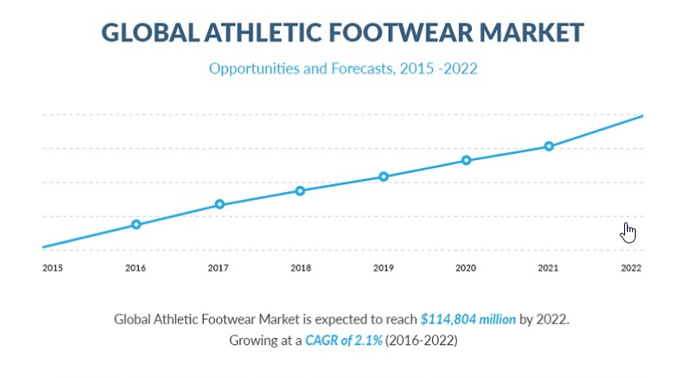

** Sports shoes are one of the most trending segments.

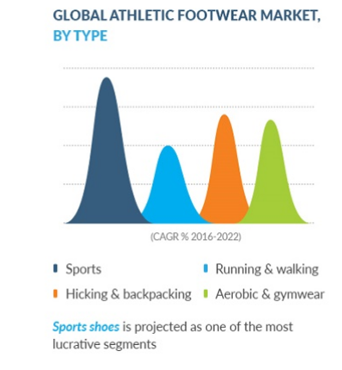

In terms of competition there are significant barriers to entry, especially with light-weight performance shoes. Reebok faces fierce competition from all sides. The athletic shoe industry is quite large and very competitive. Reebok receives most of its competition from Nike. In addition to Nike, Reebok goes up against Sketchers, Under Armour and New balance for direct competition.

Nike: It is the number one producer of athletic shoes in the world. One of Nike’s greatest strengths is brand recognition and branding. Nike’s slogan, “Just do it,” along with the famous “swoosh,” are known. Nike is continuously changing and updating its products and advertising. The company uses many different marketing strategies which are geared for several different target markets (Nike, Inc, 2010). Nike, like Reebok, does not manufacture the shoes it sells. Instead Nike hires subcontractors in other countries who manufacture the shoes. These manufacturers then ship the shoes to other companies to sell. This can be both a weakness and strength for Nike. It is a weakness because of the dependency on the overseas manufacturer. However, it is also strength because Nike’s money can now be used for expanding its product line or on a new advertising campaign instead of on the purchase and upkeep of buildings.

New Balance: New Balance’s top strength would be the technology and innovation of its new products. Every year New Balance creates a new and updated product with all the latest in technology. In addition, The New Balance Foundation has given back more than $40 million to the community and non-profit organizations. More than 50% of consumers want to purchase a product if they know that a portion of the profits will go to charity (Strahilevitz & Myers, 1997). New Balance relies on promotion through the sponsorship of races and fitness activities instead of using celebrity endorsements (Johnson, 1998). The strength of not using celebrities is that the price of the shoe will be less for the consumer since New Balance does not pay for the endorsements. However, the downside to this is that the younger generation is attracted to shoes that have been associated with top celebrities (Johnson, 1998).

Under Armour: Under Armour was founded in 1996 by Kevin Plank, a former football player with the University of Maryland. Plank came up with a synthetic textile design which enabled sweat to be "wicked-­‐away" during high levels of physical activity. Under Armour's brand mission is to make all athletes better through passion, design and the relentless pursuit of innovation (Under Armour). Since the introduction of this type of sports apparel technology, the concept has been widely copied by all the major sportswear brands. Under Armour also strategized to maintain and increase sales in North America as well as to enter foreign country markets as rapidly as was economical.

**STP Analysis:**

**Segmentation:**

Geographic: It divides the market into different units of locations – neighbourhood, states, regions cities -includes urban and semi-urban areas.

Demographic: Reebok shoes can be used by all genders and age groups. However, the demographic segmentation of Reebok tends to be for: (1) Age Groups 15-45 (2) Income levels - $15,000 (3) Gender – both male and female (4) Social class – Upper middle, upper class, lower upper.

Psychographic: Achievers, well experienced, Hard workers, Image drivers

Behavioural: Sports men/women, Gym Regulars, Brand Freaks, Athletes, Sports Lovers, free runners etc.

**Targeting:**

Reebok targets all age groups, genders and characteristics of people. Anyone in desire of fitness/exercise, into sports and a shoe-maniac could use Reebok shoes. However, Reebok has got a few specific footwear lines for different people.

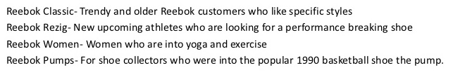

**Positioning:**

Reebok is positioned as a premium sports and lifestyle brand with a focus on fitness and training. It aims to make fitness fun through offering toning, conditioning and flexibility products. Reebok’s successful launches include EasyTone, Zigtech and RealFlex. The brand aims to contemporize itself with the youth by leveraging associations like fitness, fun, stylish and good design.

The perceptual map beneath (perhaps, an example according to our perception) shows that Reebok stands in Grid A that specifies moderately expensive and performance segment.

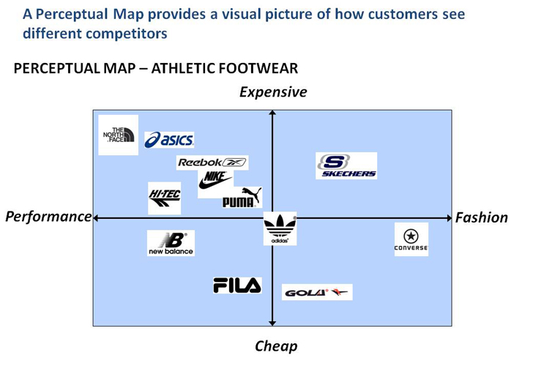

*Survey Analysis:*

According to the survey conducted by us, maximum percentage has chosen Nike followed by Reebok and Adidas. Out of the sample, most of them chose to buy shoes for “necessity” rather than variety or promotions. Necessity could point towards health, durability, comfort, value for money etc., We can see that, probably, most of the respondents choose a brand based on its comfort, durability, style, value for money in a decreasing order. 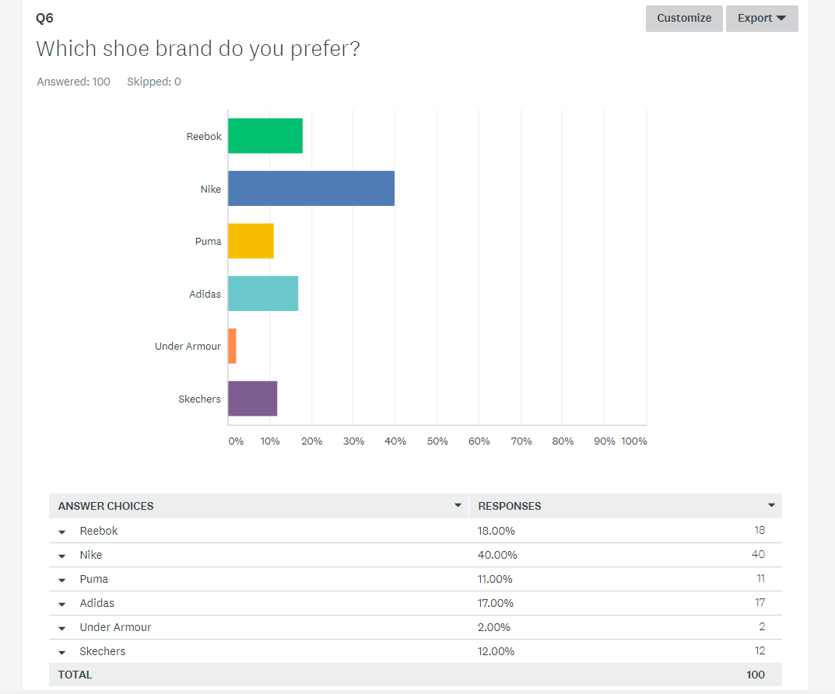 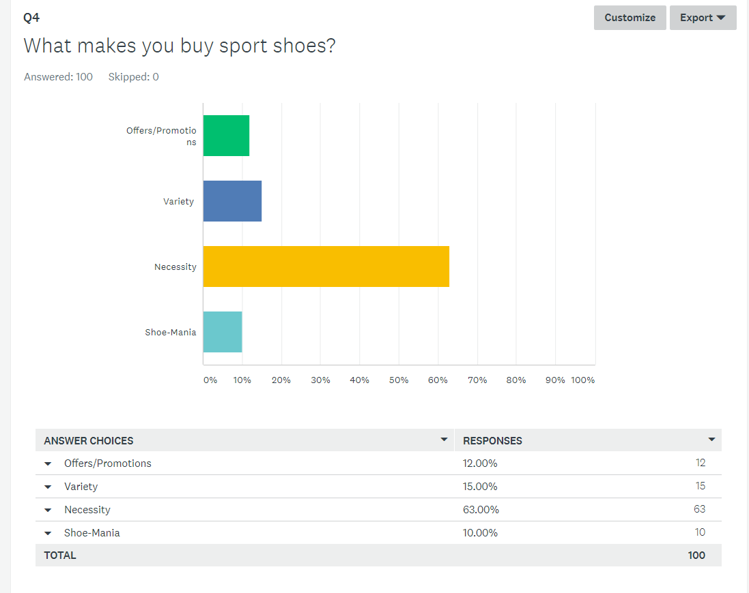

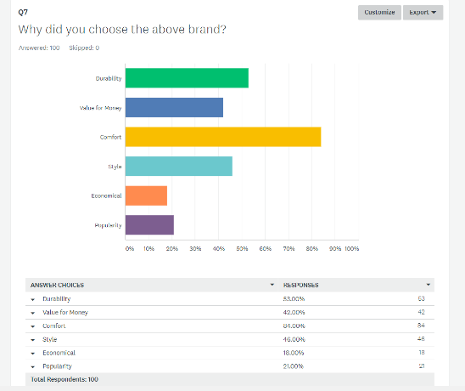

Market share of sport shoe companies:

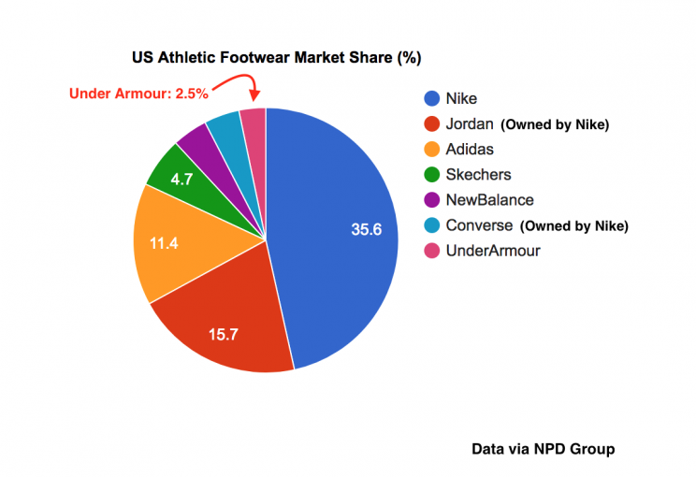

Nike holds the highest market share in the athletic footwear market. Reebok, to level up its competition and improve its potential market share, has to increase its market penetration strategies and focus on balanced marketing mix and promotional strategies.

**SWOT Analysis:**

**Strengths:**

* Reebok’s name, branding and its high-quality image.
* Service and distribution channels – operates through variety of departmental stores, sporting goods, company owned stores etc., thus, having a good reach.
* Has initial grounding in fitness market – with help of Adidas being its parent group.
* Many teenagers and youth – the segment that Reebok targets the most
* Products are made in premium and mid-ranges
* Reebok brings out the perfect combination of technology and fitness each year, in its products.
* The brand has been endorsed by many celebrities and sports stars, globally.
* It has its business spread in more than 80 countries, along with Adidas.

**Weakness:**

* It being a popular brand might be affected easily by controversies associated with any brand ambassadors. Thus, affecting the brand image considerably.
* Adidas being its parent company could affect Reebok.
* Not top brand for purchasing product merchandizes such as apparels, accessories etc.,

**Opportunities:**

* Reebok can target the kids section.
* More tie-ups with sports academies and schools, worldwide.
* Lifestyle section can be expanded, further.
* Consumer buying growth due to health-conscious society.
* The growing interest of sports in emerging economies could be targeted by Reebok.
* New and innovative sports shoe designs.

**Threats:**

* Competition from international brand – limits market share
* May face a lot of losses due to duplication of its products
* Product Cannibalization – Adidas brand can affect Reebok’s business
* Fluctuating economies/currencies could have potential effect on Reebok’s sales/revenue.
* Limited customer base

We consider Reebok going about with Diversification. It is a good way to grow one’s business when a company is seeking new portfolio or opportunities outside the current business. In Reebok’s case, any expansion strategy associate with existing market or existing product is unlikely to gain growth significantly, because of the competition in the industry. Therefore, diversification becomes the best solution.

|  |  |  |
| --- | --- | --- |
|  | Existing product | New product |
| Existing market | Market penetration | Product development |
| New market | Market development | Diversification |

**Proposed Market Strategy:**

Reebok is a worldwide brand that deals with the production and distribution of Sports apparels. We analysed Reebok’s marketing mix strategy that they have implemented for successful market penetration.

Marketing Mix elements; 4P’s – Product, Price, promotion, Place

**Product**

Running shoes contribute to the major chunk of Reebok’s revenue. Hence to keep up with the demand, Reebok releases it new models every year. It’s CrossFit Nano and the Ultra knit prime variants are gaining traction in the market and proving to be quite popular amongst athletes. As is the case with other industries, innovation and the latest fashion trend are the key factors that drive the sales for a product. Reebok had seen a steady decline in its revenue 3 years ago. However, it has managed to revamp itself by forming a 40-person team to design products that weren’t just focused on comfort and function but also on provided high-tech in their shoes. Reebok recently unveiled its latest footwear innovation, a process of assembling sole technology by using 3D printing to create dynamic outsoles that are as responsive as they are shapely. Thus, Reebok is making advancement in technology to keep up with Nike’s Air max range.

**Pricing**

Reebok is known for its pricing in the market and its strategy on penetrating in the market with low introductory prices. In the launch of a new product it follows skimming policy. It has got Competitive Market pricing. The company ensures the quality is maintained with the product pricing. Reebok maintains its reputation as middle priced brand when compared to Nike and Adidas. Reebok suddenly comes with destroyer pricing policy at times to tackle Puma and Nike’s competition. They maintain good frequency of promotional sales throughout the year to increase customer base and maintain customer satisfaction. They utilize a 100% outsourcing strategy and manufacture their products throughout Asia leading to a low initial investment and better profit margins.

**Promotion**

Reebok’s promotion strategy involves holding onto the current customers and at the same time tap into newer markets and penetrate deeper into the existing markets. Reebok uses Commercials, celebrities and billboards as ways to make its target customer aware about its offers. Reebok should expand its social media activities to create a buzz about its new set of products, as that is one area where Reebok lags as compared to other competing brands such as Nike and Adidas. Reebok should stress on promoting their products through campaigns such as “I Am what I Am" to connect with their potential customers on an emotional level and which can help them drive their sales further.

**Placement**

In the international market, Reebok has many distributors, licenses and subsidiaries which sell its products. In the US, 60 percent of Reebok’s sales come through wholesale channels, while 40 percent are direct-to-consumer (primarily through Reebok-operated stores). Reebok shoes are sold by other multi brand stores and exclusive Reebok stores worldwide Reebok makes shoes in at least a dozen factories in several countries but most of them are in Asia. Reebok should focus on more visibility in the outlets to capture the market attention since 63% of the purchases made in US are through outlets. It should try to target places of teens and women where there is a high proportion for sales. Reebok also improved its brand promotions at outlets during Thanksgiving sales in US compared to last year.

**Future Scope:**

Reebok has wider range of products for Men, now it’s the time that the company should also focus on developing broader range of Women Shoes. For this, it should do more emotional endorsement by popular personalities for lasting effect on the audience. It should build brand with influencers to make it authentic. Reebok should have more promotional coupons, which helps in calling customers back to the company, for redemption and new buying behaviour. With addition to this rebate, sales promotion events, and concerts etc can be organized for large customer base and brand awareness.

As per the survey, we came across the fact that maximum customers prefer to buy shoes in the range of $25- $50. So, Reebok could expand the market share for lower priced shoes. This leads to market-penetration pricing to attract bulk customers. Further, maintaining a loyal customer base is an important way, this can take place if company offer them extra benefits or premiums if they purchase above 40 shoes in a year. Let the consumers have what they want, give them the option to customize their shoes.

**Conclusion:**

We should create more buzz for the brand, if brand Reebok creates limited edition version they make them rare and consequently people get more excited to buy if the product is limited. Higher prices of this segment attract customers who thinks higher the prices, higher will be the performance. On the other hand, promotional pricing of Reebok can attract price sensitive consumers. In this way, it will occupy more consumer base. Also, with wide variety of women shoes, it can reissue its classic edition and make them look more attractive and different. For this Reebok should create hype online and control the amount of supply- its rarity will increase the demand rapidly.